Manual Testing Report- Guru99 Payment Gateway Demo Application

https://demo.guru99.com/payment-gateway/index.php

Submitted by: Rahul Ananad
Submitted to: Shamsheera T
AF ID: AF05075429
Batch: ANP-D1934

1.PROJECT OVERVIEW
This project involves manual testing of the Guru99 Payment Gateway Demo Application, which simulates an online payment process using card details.
The main objective of testing this application is to ensure that:
- The payment page loads correctly
- Mandatory fields are validated properly
- Valid payment details allow successful submission
- Invalid card details show appropriate error messages
- Dropdowns and input fields behave correctly
- Navigation between pages works as expected
- UI elements are properly aligned and readable

Test Module for Testing:
  - Homepage Module
  - Navigation Module
  - UI & Usability Module
  - Responsiveness Module
  - Error Handling Module

2.Test Plan
Application Name: Guru99 Payment Gateway
Testing Type: Manual Testing (Functional, UI, Validation)
Environment: Chrome, Firefox, Edge
Tools Used: Browser Developer Tools, Word , Screenshot Tool
In Scope:
- Payment form validation
- Card number field validation
- CVV and expiry date validation
- Dropdown behaviour
- Submit behaviour
- Navigation flow
- UI alignment and labels

Out of Scope:
- Backend payment processing
- Database validation
- Security penetration testing

Entry Criteria:
- Website must be accessible
- Test environment ready
- Test data available

Exit Criteria:
- All test cases executed
- All major defects logged

Deliverables:
- Test plan
- Test Scenarios
- Test Cases
- Bug Report
- Test Summary Report

Field | Details
Project Name | Guru99 Payment Gateway Testing
Application URL | https://demo.guru99.com/payment-gateway/index.php
Tested By | Rahul Anand
Testing Type | Manual Testing
Test Environment | Chrome, Firefox, Edge
Tools Used | Browser Dev Tools, Word
Start Date | 10-Jan-2026
End Date | 11-Jan-2026
In-Scope Modules | Payment Form, Validation, UI
Out of Scope | Backend processing
Entry Criteria | Site accessible
Exit Criteria | All test cases executed
Deliverables | Test cases, Bug Report, Summary

3.Test Scenarios
Scenario ID | Description
TS01 | Verify payment page loads successfully
TS02 | Verify all mandatory fields are present
TS03 | Verify valid card details submission
TS04 | Verify invalid card number validation
TS05 | Verify empty form submission
TS06 | Verify CVV field validation
TS07 | Verify expiry month and year selection
TS08 | Verify successful payment confirmation
TS09 | Verify UI alignment and labels
TS10 | Verify HTTPS security
TS11 | Verify browser back navigation
TS12 | Verify reset functionality
TS13 | Verify numeric-only fields
TS14 | Verify page responsiveness

4.Test cases
TC ID | Description | Test Steps | Test Data | Expected Result
TC01 | Page load | Open URL | — | Page loads successfully
TC02 | Mandatory fields | Check form | — | All mandatory fields visible
TC03 | Valid card payment | Enter valid data → Submit | Valid card | Payment successful
TC04 | Invalid card number | Enter wrong number | 123456 | Error message shown
TC05 | Empty form | Click submit | Blank | Validation error
TC06 | CVV validation | Enter invalid CVV | 12 | Error shown
TC07 | Expiry date | Select month/year | Future date | Accepted
TC08 | Payment confirmation | Submit valid form | — | Order ID generated
TC09 | UI alignment | Observe layout | — | Proper alignment
TC10 | HTTPS | Check URL bar | — | Secure HTTPS
TC11 | Back navigation | Click back | — | Navigates correctly
TC12 | Reset behaviour | Refresh page | — | Form cleared
TC13 | Numeric fields | Enter alphabets | abc | Not accepted
TC14 | Responsiveness | Resize window | — | Layout stable

5.RTM Report
Req ID | Requirement | Test Case ID | Priority | Status | Remarks
RE01 | Page should load correctly | TC01 | High | Pass | Loaded
RE02 | Mandatory fields validation | TC05 | High | Fail | No message
RE03 | Valid payment | TC03 | High | Pass | Successful
RE04 | Invalid card validation | TC04 | High | Fail | Weak validation
RE05 | CVV validation | TC06 | Medium | Fail | Accepts short CVV
RE06 | HTTPS security | TC10 | High | Pass | Secure
RE07 | UI consistency | TC09 | Medium | Pass | Aligned
RE08 | Numeric-only fields | TC13 | Medium | Fail | Accepts alphabets
RE09 | Responsive design | TC14 | Low | Pass | Stable

6.Bug Report

Bug ID | Description | Severity | Status | Screenshots
BUG01 | Form submits with empty fields | Major | Open | 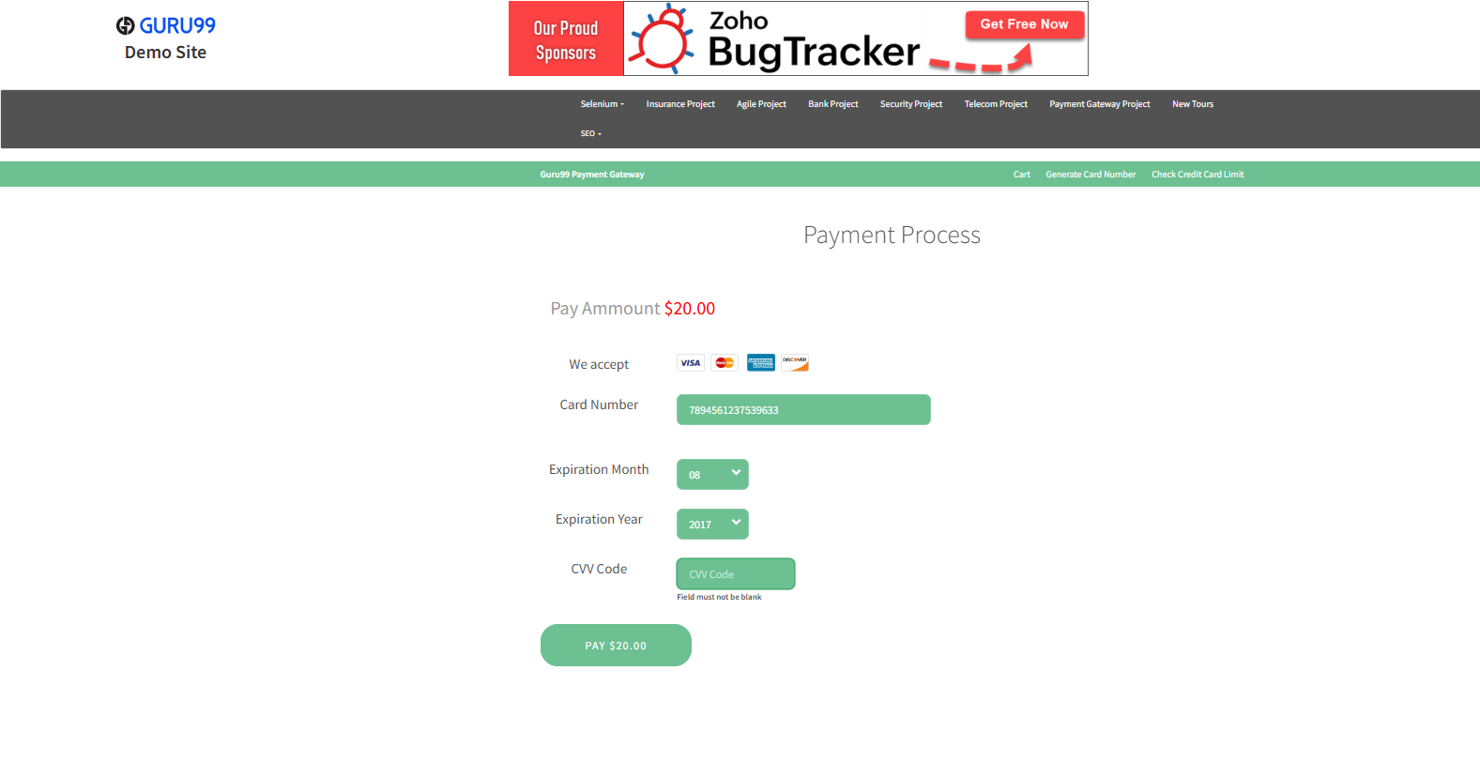
BUG02 | Card number accepts alphabets | Major | Open | 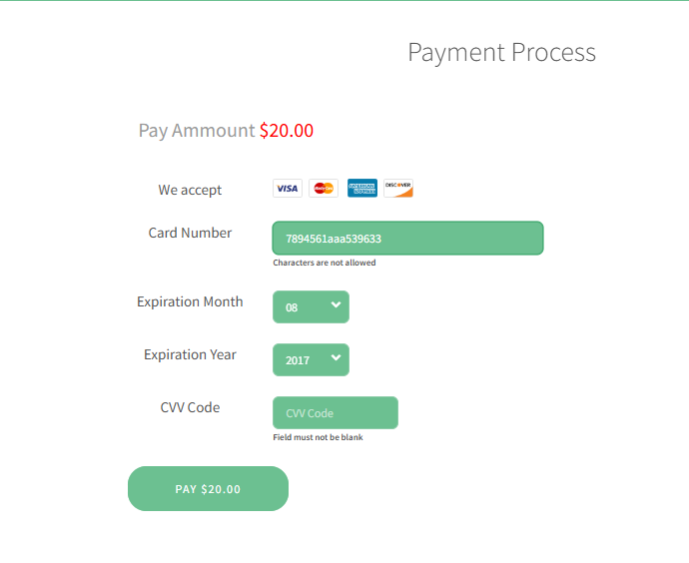
BUG03 | CVV accepts less than 3 digits | Medium | Open | 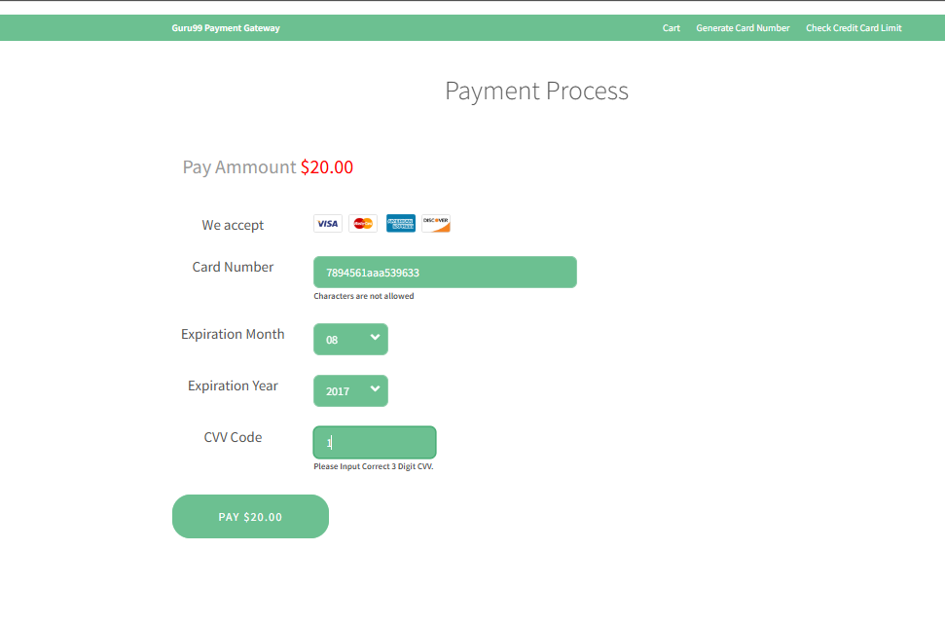
BUG04 | No proper error message for invalid card | Major | Open | 
BUG05 | Expiry date allows past year | Medium | Open | 
BUG06 | No inline validation hints | Minor | Open | 

7.Test Summary Report
Testing Duration: 2 days (10–Jan–2026 to 11–Jan–2026)
Total Test Cases: 14
Passed: 8
Failed: 6
Blocked: 0
The Guru99 Payment Gateway demo application was tested for functional correctness, validation, and UI behaviour. Most core functionalities work as expected, including successful payment with valid data, page navigation, dropdown behaviour, and HTTPS security.
However, several validation-related defects were identified, particularly around mandatory field checks, card number validation, and CVV constraints. These issues can lead to incorrect or incomplete data submission, which affects reliability.

Defect Statistics
- Total Defects: 6
- Major: 3
- Medium: 2
- Minor: 1
- Open: 6
- Closed: 0

During the manual testing cycle of the Payment Gateway application, a total of six defects were identified across different functional areas of the system. Out of these, three defects were classified as major, as they directly affect critical payment form functionality. These include submission of empty forms without validation, acceptance of alphabetic characters in the card number field, and the absence of proper error messages for invalid card details.
Two defects were categorized as medium, mainly related to CVV validation and expiry date handling. The system allows CVV values with less than the required number of digits and accepts past expiry dates, which may lead to incorrect or invalid payment attempts.
One defect was marked as minor, related to the absence of inline validation hints, which affects usability but does not block the payment flow.
At the time of documentation, all six defects remain in an open state and are pending resolution. Although no critical defects were identified, the presence of multiple major and medium issues indicates the need for improved input validation and error handling. These defect statistics reflect the current stability of the application and will help the development team prioritize fixes before moving to the next testing or deployment phase.

Observations
During the execution of manual testing on the Guru99 Payment Gateway application, several observations were identified that impact user experience and system reliability.
- The payment form allows submission even when mandatory fields are left empty.
- The card number field accepts alphabetic characters instead of restricting input to numeric values.
- The CVV field accepts less than the required number of digits.
- The expiry date field allows selection of past months and years.
- Proper error messages are not displayed for invalid or incorrect card details.
- Inline validation hints are missing, which makes it difficult for users to correct errors.
Overall, the payment form lacks strong input validation and clear user guidance. While the basic payment flow functions correctly, the absence of proper validation messages and input restrictions can lead to incorrect data submission. These issues reduce reliability and may affect user trust during payment transactions. Improvements are required to ensure secure, accurate, and user-friendly payment processing.

Conclusion
The Guru99 Payment Gateway demo application provides a basic and effective simulation of an online payment system. The user interface and overall workflow are simple and easy to understand, making the application suitable for learning and demonstration purposes.
However, the testing results reveal several validation-related issues that need attention. Critical validations such as mandatory field checks, numeric-only enforcement for card numbers, CVV length validation, and expiry date verification must be strengthened. Additionally, meaningful error messages and inline validation hints should be implemented to improve usability and prevent incorrect data submission.
Overall, while the application is stable for educational use, validation enhancements are required before it can be considered reliable for real-world payment scenarios.

